**GROUP PROJECT, GROUP 3**

**DATE: 6th November 2018**

**TIME: 11:00 – 15:00**

**ATTENDEES** Tom Gibbs, Henry Crofts

**LOCATION:** A216, ATRIUM

**Minute Taker: Henry Crofts**

**Overall aims of the current sprint *(Detailed tasks, user stories and time allocations are tracked on JIRA)***

* Create Slides for PowerPoint
* Create Screen Mock Ups for PowerPoint
* Collect Design Ideas and Theories ready for PowerPoint
* Rehearse PowerPoint.
* Continue working in a Studio Environment

**Meeting:**

All team present.

The team met up today to discuss the weeks tasks, what was needed, and what was of a lower priority. We decided that the weeks tasks would still be to prepare for the presentation so as a team we walked through the various steps of the game, deciding which screens to make a mock-up of to show during the presentation. The screen mock-ups we have decided to show from the tutorial level are;

* The start of the level
  + This mock-up will show what the players will see when the first start the game, after pressing play on the menu screen for the first time.
* The cargo hold showing a form of animation
  + To encourage the player to go towards the cargo hold to get out an item we have decided to use animations to inspire the players curiosity using telegraphing.
* The UI Overlay of the cargo hold
  + Once the player gets into range of the cargo hold, a UI element will show for them, instructing them what each button will retrieve which resource from the hold.
* Once the player has got an item out of the cargo hold another interactable that their item can be used on will be presented to them.
  + For example, if the player gets a cannonball out of the cargo hold, during the tutorial session the cannon will start to throb or play some other form of animation to show the player where to take the cannonball.
* We then decided to show a screen of what the cannon would look like when it has been fully loaded, this will allow the player to know when the cannon is able to be fired when an enemy ship enters the hit zone.
* Because the crow’s nest will be a valuable part of the player’s experience we decided to create a screen mock-up to show how this will work within the game, calling out hazards such as an enemy ship approaching, or a rock in front of the ship.
* Following on from the crow’s nest call outs, once the NPC has shouted out that an enemy is approaching, there will be a flag appear on the side of the screen that it appears, this will show where the enemy is relative to the player ship.
  + Once the flag reaches the hit zone, if the players have loaded the cannons correctly, they will then be able to fire at the enemy ship, causing damage or destroying it.
* 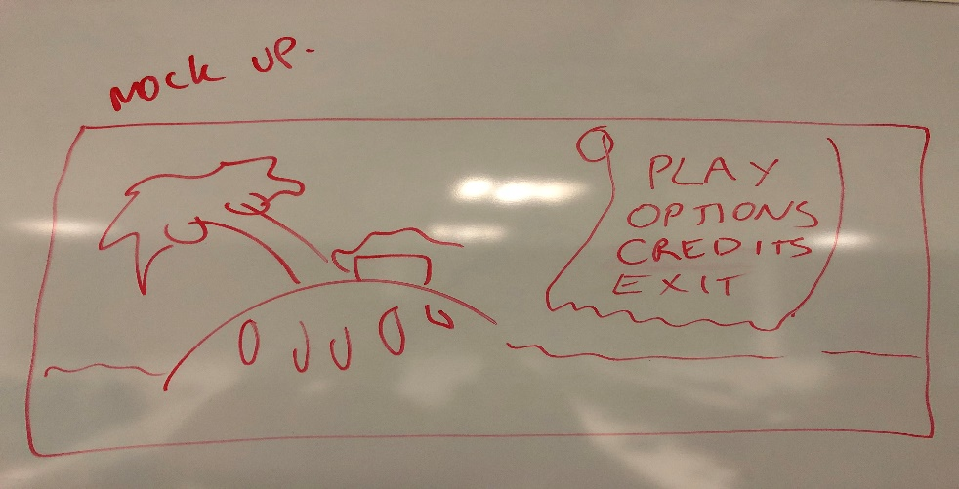We also discussed a menu screen mock up and drew it out on a whiteboard.
  + This screen would play an animation with the water and have the characters looking around the island for some treasure.
* 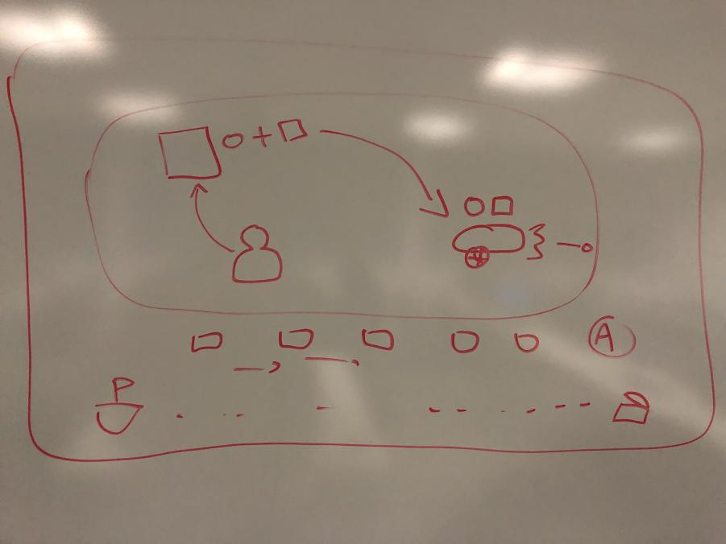We then spoke about having the tutorials / tips on the loading screen.
  + This is to help show the player how objects in the scene can be interacted with, hopefully this will allow players to be continuously taking in information and following the “Learn-Practice-Master” loop.

After showing mock-ups for the tutorial level, we also decided to create some screenshots for how we intend the level to look after; 5 seconds, 20 seconds, 40 seconds, 1 minute, 2 minutes and 5 minutes, to show how we intend to ramp the difficulty and start to stress the players by having too much happening at any one time.

After talking about the presentations, we spoke on a few aspects of the game, while importing assets into our Unity build we discussed the potential of having the camera look at the side of the ship, rather than behind it. However, we found that this would not work with how we have designed the game, trying to mitigate as many risks as we can, we decided not to model and show any enemy ships, so for now, the camera will continue to be behind the ship.

We also discussed how players would be able to identify their avatars quickly while in the manic world, and although we will be implementing a customisation system to allow players to have their own style, some players might select the same outfits. To overcome this, we have decided to give each player a colour, for example; player 1 = red, player 2 = blue etc. We would then put a ring around the feet of the player, this will allow players to identify the different avatars quickly to know who is where, on the ship.

Rewards came up towards the end of the meeting, with team discussing various techniques, such as; Reward Ratio, Reward Scheduling and Objectives. Within the level there will be X number of optional objectives to complete, the objectives will give the players a sense of achievement as they finally reach their goal, as they complete challenges, the guaranteed “End Game” chest will have a better chance of producing a higher quality piece of gear. We will also be able to afford progression, by giving the players some progress towards completing the objective from the tutorial, this will give players a chance to continue the progress since it is already started.

**Tasks for the current week:**

**Tom (7 Hours):**

* **Produce Screen Mock Up to Show the Level Start (15m)**

To be completed in a studio jam environment on Wednesday 7th November – Produce a screenshot showing what the beginning of the tutorial level will look like.

* **Produce Screen Mock Up to Show the Cargo Hold “Animating” for Cannonball (15m)**

To be completed in a studio jam environment on Wednesday 7th November – Produce a screenshot showing the cargo hold in an animation state to encourage the player to move there.

* **Produce Screen Mock Up to Show the UI Overlay on the Cargo Hold for the Cannonball (15m)**

To be completed in a studio jam environment on Wednesday 7th November – Produce a screenshot showing the UI overlay instructing the player to select the correct button to grab a cannonball from the cargo hold.

* **Produce Screen Mock Up to Show the Cannon Throbbing (15m)**

To be completed in a studio jam environment on Wednesday 7th November – Produce a screenshot showing the cannon “throbbing” to encourage the players to take the cannonball and load it into the cannon.

* **Produce Screen Mock Up to Show the Cargo Hold “Animating” for Gunpowder (15m)**

To be completed in a studio jam environment on Wednesday 7th November – Produce a screenshot showing a different animation for the cargo hold in an animation state to encourage the player to move there.

* **Produce Screen Mock Up to Show the UI Overlay on the Cargo Hold for the Gunpowder (15m)**

To be completed in a studio jam environment on Wednesday 7th November – Produce a screenshot showing the UI overlay instructing the player to select the correct button to grab the gunpowder from the cargo hold.

* **Produce Screen Mock Up to Show the Cannon Throbbing (15m)**

To be completed in a studio jam environment on Wednesday 7th November – Produce a screenshot showing the cannon “throbbing” to encourage the players to take the gunpowder and load it into the cannon.

* **Produce Screen Mock Up to Show the Cannon Fully loaded (15m)**

To be completed in a studio jam environment on Wednesday 7th November – Produce a screenshot showing the cannon in a fully loaded state.

* **Produce Screen Mock Up to Show the Crow’s Nest Callouts (15m)**

To be completed in a studio jam environment on Wednesday 7th November – Produce a screenshot showing the Crow’s Nest performing a call out.

* **Produce Screen Mock Up to Show the Enemy Flag on Side of Screen (15m)**

To be completed in a studio jam environment on Wednesday 7th November – Produce a screenshot showing the enemy flag on the side of the screen showing the enemies current location.

* **Produce Screen Mock Up to Show the Cannon Firing(15m)**

To be completed in a studio jam environment on Wednesday 7th November – Produce a screenshot showing the cannon firing upon the enemy and debris floating around the ship.

* **Rehearse for Presentation (2h)**

To be completed in a studio jam environment on Wednesday 7th November – Rehearse for the presentation on Monday 12th November.

* **Produce slide for PowerPoint on Reward Ratios (30m)**

To be completed in a studio jam environment on Wednesday 7th November – Complete the slide for the reward ratio section of the project.

* **Produce slide for PowerPoint to Show the Game at 5 Seconds (15m)**

To be completed in a studio jam environment on Wednesday 7th November – Complete the slide to show the state of the game at 5 Seconds.

* **Produce slide for PowerPoint to Show the Game at 20 Seconds (15m)**

To be completed in a studio jam environment on Wednesday 7th November – Complete the slide to show the state of the game at 20 Seconds.

* **Produce slide for PowerPoint to Show the Game at 40 Seconds (15m)**

To be completed in a studio jam environment on Wednesday 7th November – Complete the slide to show the state of the game at 40 Seconds.

* **Produce slide for PowerPoint to Show the Game at 1 Minute (15m)**

To be completed in a studio jam environment on Wednesday 7th November – Complete the slide to show the state of the game at 1 Minute.

* **Produce slide for PowerPoint to Show the Game at 2 Minutes (15m)**

To be completed in a studio jam environment on Wednesday 7th November – Complete the slide to show the state of the game at 2 Minutes.

* **Produce slide for PowerPoint to Show the Game at 5 Minutes (15m)**

To be completed in a studio jam environment on Wednesday 7th November – Complete the slide to show the state of the game at 5 Minutes.

* **Combine all slides together for the PowerPoint (1h)**

To be completed in a studio jam environment on Wednesday 7th November – Work on combining all the slides together and rearranging as necessary during the rehearsal.

**Henry (7 Hours):**

* **Produce Screen Mock Up to Show the Level Start (15m)**

To be completed in a studio jam environment on Wednesday 7th November – Produce a screenshot showing what the beginning of the tutorial level will look like.

* **Produce Screen Mock Up to Show the Cargo Hold “Animating” for Cannonball (15m)**

To be completed in a studio jam environment on Wednesday 7th November – Produce a screenshot showing the cargo hold in an animation state to encourage the player to move there.

* **Produce Screen Mock Up to Show the UI Overlay on the Cargo Hold for the Cannonball (15m)**

To be completed in a studio jam environment on Wednesday 7th November – Produce a screenshot showing the UI overlay instructing the player to select the correct button to grab a cannonball from the cargo hold.

* **Produce Screen Mock Up to Show the Cannon Throbbing (15m)**

To be completed in a studio jam environment on Wednesday 7th November – Produce a screenshot showing the cannon “throbbing” to encourage the players to take the cannonball and load it into the cannon.

* **Produce Screen Mock Up to Show the Cargo Hold “Animating” for Gunpowder (15m)**

To be completed in a studio jam environment on Wednesday 7th November – Produce a screenshot showing a different animation for the cargo hold in an animation state to encourage the player to move there.

* **Produce Screen Mock Up to Show the UI Overlay on the Cargo Hold for the Gunpowder (15m)**
* To be completed in a studio jam environment on Wednesday 7th November – Produce a screenshot showing the UI overlay instructing the player to select the correct button to grab the gunpowder from the cargo hold.
* **Produce Screen Mock Up to Show the Cannon Throbbing (15m)**

To be completed in a studio jam environment on Wednesday 7th November – Produce a screenshot showing the cannon “throbbing” to encourage the players to take the gunpowder and load it into the cannon.

* **Produce Screen Mock Up to Show the Cannon Fully loaded (15m)**

To be completed in a studio jam environment on Wednesday 7th November – Produce a screenshot showing the cannon in a fully loaded state.

* **Produce Screen Mock Up to Show the Crow’s Nest Callouts (15m)**

To be completed in a studio jam environment on Wednesday 7th November – Produce a screenshot showing the Crow’s Nest performing a call out.

* **Produce Screen Mock Up to Show the Enemy Flag on Side of Screen (15m)**

To be completed in a studio jam environment on Wednesday 7th November – Produce a screenshot showing the enemy flag on the side of the screen showing the enemies current location.

* **Produce Screen Mock Up to Show the Cannon Firing(15m)**

To be completed in a studio jam environment on Wednesday 7th November – Produce a screenshot showing the cannon firing upon the enemy and debris floating around the ship.

* **Rehearse for Presentation (2h)**

To be completed in a studio jam environment on Wednesday 7th November – Rehearse for the presentation on Monday 12th November.

* **Produce foundation for the PowerPoint (30m)**

To be completed in a studio jam environment on Wednesday 7th November – Complete the slide for the reward ratio section of the project.

* **Produce slide for PowerPoint to Show the Mock Up for Fetch Cannonball and the Cargo Hold UI Overlay (15m)**

To be completed in a studio jam environment on Wednesday 7th November – Complete the slide to show how the game will show the player to get the cannonball from the cargo hold.

* **Produce slide for PowerPoint to Show the Mock Up for the Load Cannonball tutorial (15m)**

To be completed in a studio jam environment on Wednesday 7th November – Complete the slide to show how the game will show the player to load the canons.

* **Produce slide for PowerPoint to Show the Mock Up of Fetch Gunpowder and the Cargo Hold UI Overlay (15m)**

To be completed in a studio jam environment on Wednesday 7th November – Complete the slide to show how the game will show the player to get the gunpowder from the cargo hold.

* **Produce slide for PowerPoint to Show the Mock Up of the fully loaded cannon (15m)**

To be completed in a studio jam environment on Wednesday 7th November – Complete the slide to show how the game will inform the player the cannon is fully loaded.

* **Produce slide for PowerPoint to Show the Mock Up of the Crow’s Nest Call Outs (15m)**

To be completed in a studio jam environment on Wednesday 7th November – Complete the slide to show how the game will use the crow’s nest call outs.

* **Produce slide for PowerPoint to Show the Mock Up of the Cannon Fired Stage (15m)**

To be completed in a studio jam environment on Wednesday 7th November – Complete the slide to show how the game will inform the player the cannon has been fired and damaged the enemy ship.

* **Combine all slides together for the PowerPoint**

To be completed in a studio jam environment on Wednesday 7th November – Work on combining all the slides together and rearranging as necessary during the rehearsal.

* **Produce slide for PowerPoint to Show the Flow Chart of the Game (15m)**

To be completed in a studio jam environment on Wednesday 7th November – Complete the slide to show the flow that the players will get into while playing the game.

* **Produce slide for PowerPoint to show the progress and milestones for the project (15m)**

To be completed in a studio jam environment on Wednesday 7th November – Complete the slide to show our projected progress and milestones over the course of the project.

***Detailed tasks, task descriptions, user stories and time allocations are tracked on JIRA.***